
Incorporating Abbotsbury, Portesham, Langton Herring and Fleet
CHESIL BANK PARISH COUNCIL
The next Parish Council meeting will be held on
Monday 3rd September 2018
7.30pm at Portesham
All welcome!
Chesil Bank Fayre 2018
Well after postponing the event for a week due to the dramatic change in the weather, we were very lucky that most of the stall holders could attend the following week. We did have a few hiccups that were overcome on the day. It turned out to be a glorious sunny day and most could secure a little shade from the blistering heat; the dogs coped admirably and were treated to a dip in the stream after their classes. The helicopter took its passengers for a tour of the parishes and the tennis ball drop was a success, the Mill Street Jazz band entertained everyone before the dog show commenced. Many visited the fayre this year and visited the many stalls, crafts and games available on the day, the Bar and Ice cream van were very busy.
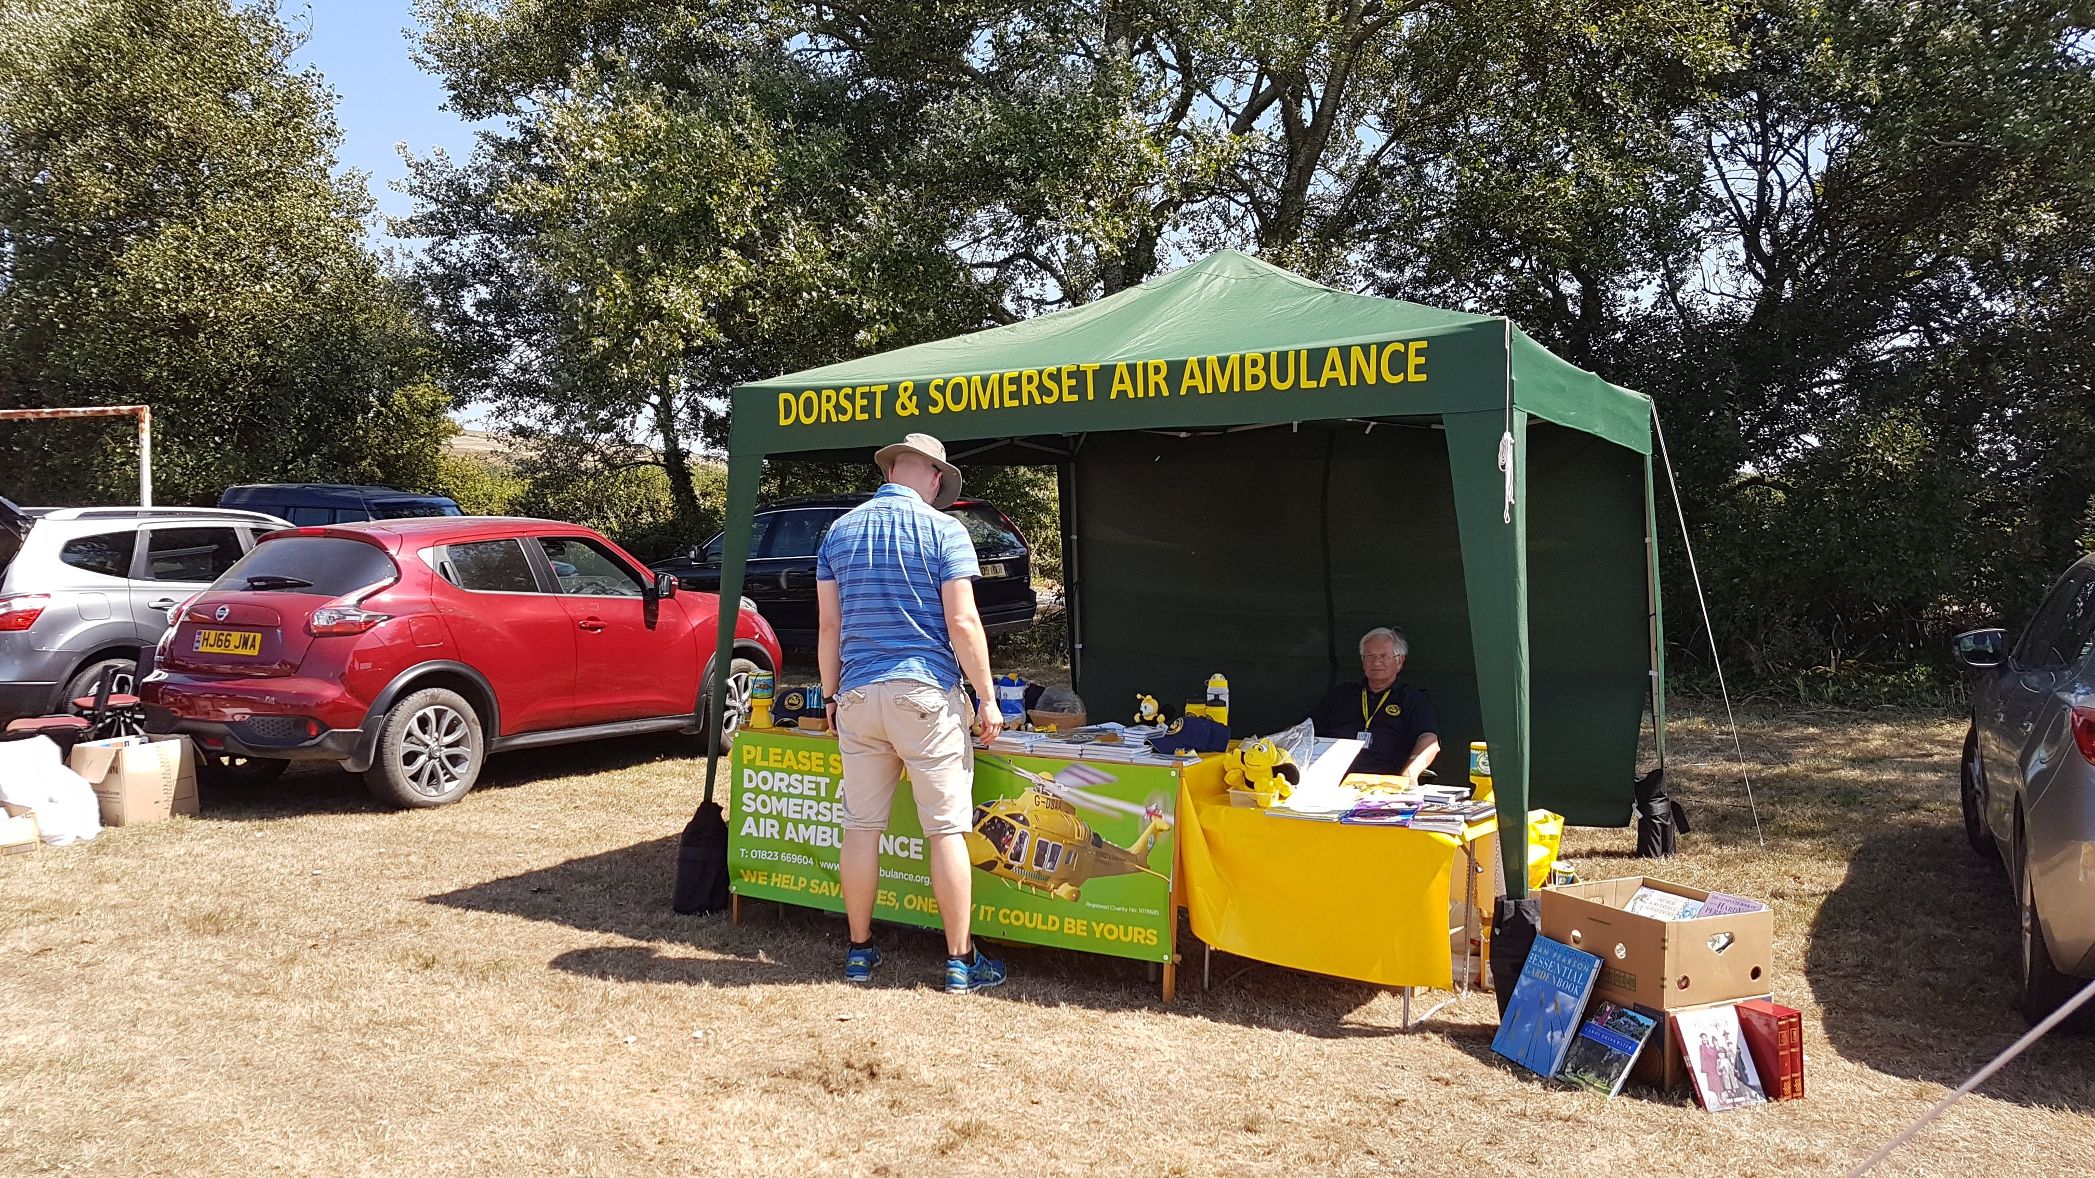
The Chesil Fayre team would like to say a huge thank you to all who helped make this event happen and to the many sponsors and volunteers.
The event raises funds for the Dorset & Somerset Air Ambulance and towards a community/sports hut for the site, this year the event raised in excess of £3800.

More photos from the event can found on the Parish Council website and Facebook page

Chesil Internet Café
13th & 27th September 2018
Ron Doble room from 10-12
Please Contact Marsha on 871446 or the Clerk for more details

The Agenda for the next meeting will be published 3 clear days in advance of the meeting and placed on notice boards in the 4 parishes; all the supporting documents for the meeting can be found on the PC website prior to the meeting
To contact the Council: The Clerk, Mrs M Harding, West Elworth Farm, Portesham, Weymouth, Dorset, DT3 4HF
Mob: 07814 016971 Email: theclerk@chesilbankparish.org Website: www.chesilbankparish.org
Facebook page-search https://www.facebook.com/Chesilbankparish/ Twitter- https://twitter.com/Chesil_Bank

