
Incorporating Abbotsbury, Portesham, Langton Herring and Fleet
CHESIL BANK PARISH COUNCIL
The next Parish Council meeting will be held on
Monday 1st October 2018
7.30pm at Langton Herring
All welcome!

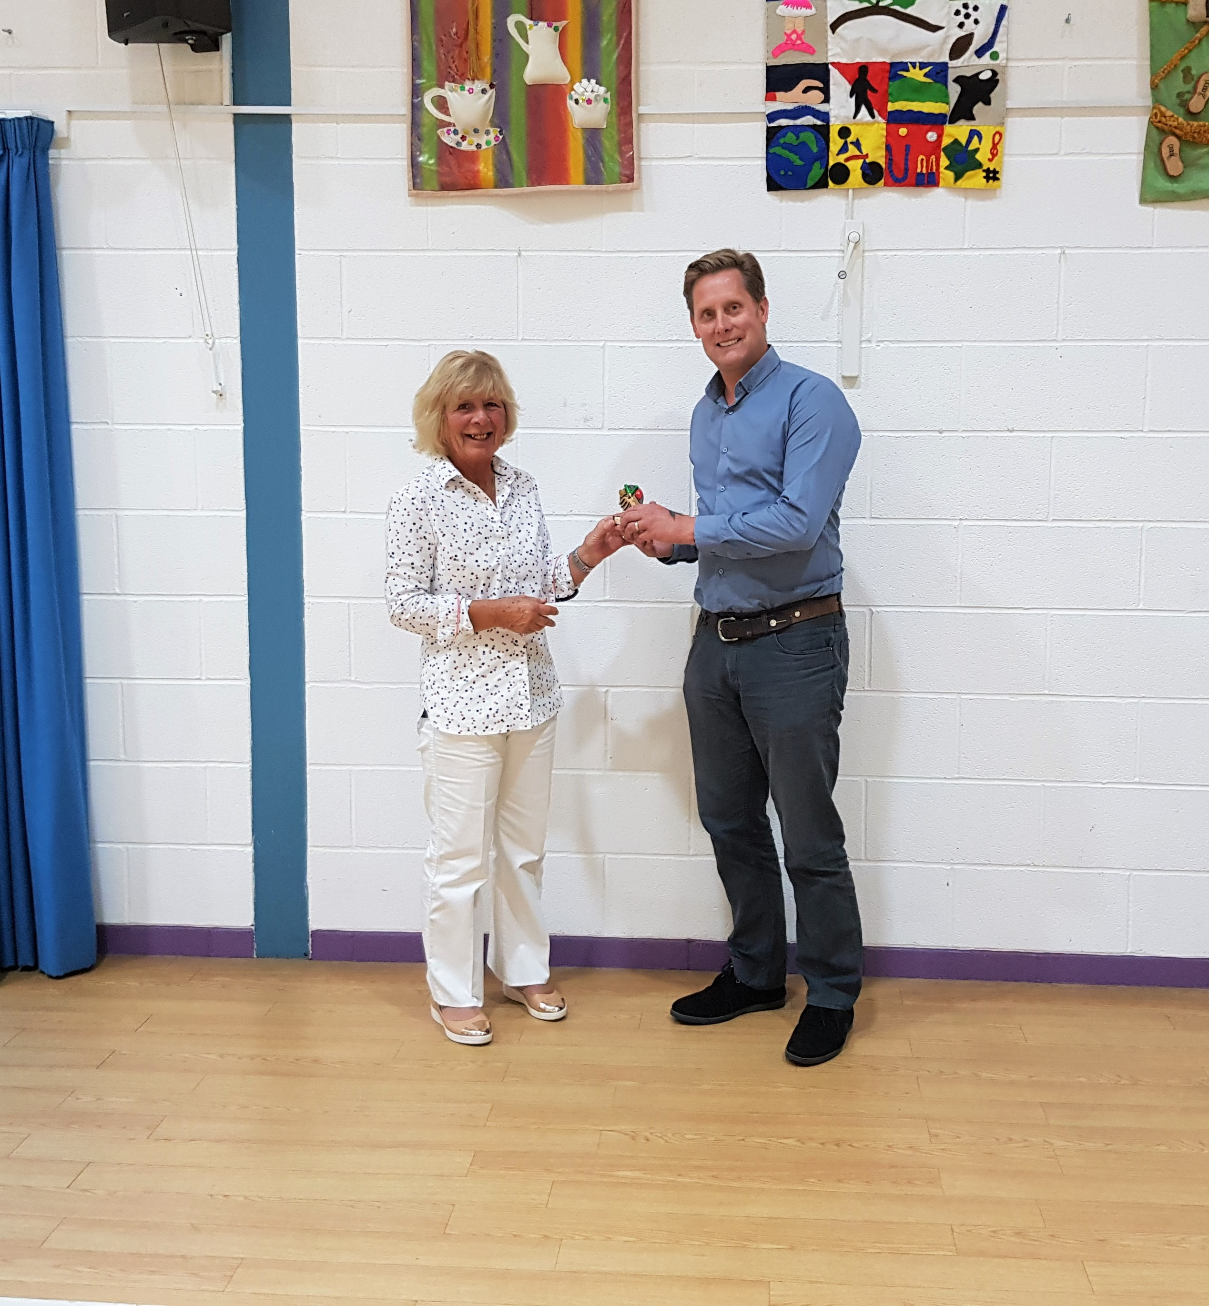
Allotment Award 2018

The Allotments at West Elworth were judged in July by Cllrs Collins, Donnelly also Robert and Barbara Fraser, Robert was instrumental in the creation of the Allotments in 2009.
The Allotments although having a dry summer were in excellent condition and production was good.
It was a close decision but well done to Jason Garrett and his Mum Marlene the winner for 2018

The Allotments and Playing field how have a waterless toilet installed on site this was purchased with S106 grant funding and thanks to those who assisted with its installation. Full instructions on how to use this facility are in the toilet

Parish & Neighbourhood Plan for Chesil Bank Parish
The NP/PP working group have arranged a core group meeting on 22nd October at 7pm at Portesham VH for all those who expressed an interest in the parishes in moving these plans forward. If you would like to be involved or would like to be on the working group please contact the Clerk in the first instance, we look forward to hearing from you….

Chesil Internet Café
11th & 25th October 2018
Ron Doble room from 10-12
Please Contact Marsha on 871446 or the Clerk for more details

The Agenda for the next meeting will be published 3 clear days in advance of the meeting and placed on notice boards in the 4 parishes; all the supporting documents for the meeting can be found on the PC website prior to the meeting
To contact the Council: The Clerk, Mrs M Harding, West Elworth Farm, Portesham, Weymouth, Dorset, DT3 4HF
Mob: 07814 016971 Email: theclerk@chesilbankparish.org Website: www.chesilbankparish.org
Facebook page-search https://www.facebook.com/Chesilbankparish/ Twitter- https://twitter.com/Chesil_Bank

